Fitness Bingo #3
Complete as many squares as you can!
Play Rock Paper Scissor with a family member.  If you win = Dance for 30 seconds  If you tie = Walk like a crab for 30 seconds  If you lose = Do 10 push-ups  Suggestions:  Play multiple rounds  Make up your own game | Food Label Frenzy  Find a Food Label on the side of a box of food.  How many Sugars do you see? Do that many jumping jacks (example 26 grams, do 26 jumping jacks)  How many Carbohydrates? Do that many push ups  How much Fat? Do that many crunches or sit-ups  How much Protein? Do that many Mountain climbers  Repeat this activity with 2-3 other food labels. | Mindfulness Matters  Perform Hot Chocolate Breathing for 10-15 minutes  -Lay down  -Relax your body  -clear your mind  -Smell the Hot Chocolate (breathe in through your nose)  -Cool off the Hot Chocolate (Exhale/Breathe out through your mouth)  -Repeat  -While doing this deep breathing, imagine you are at your favorite place.
Set The Menu!  Talk with who takes care of you about choosing the dinner menu. Pick items that are healthy and yummy.  Be sure to include the 5 food groups!  GRAINS  VEGETABLE  FRUITS  PROTEIN  DAIRY  Don’t forget to drink your water too! | Free Space!  **Additionally, Students are encouraged to participate in 20-30 minutes of moderate to vigorous physical activity daily.  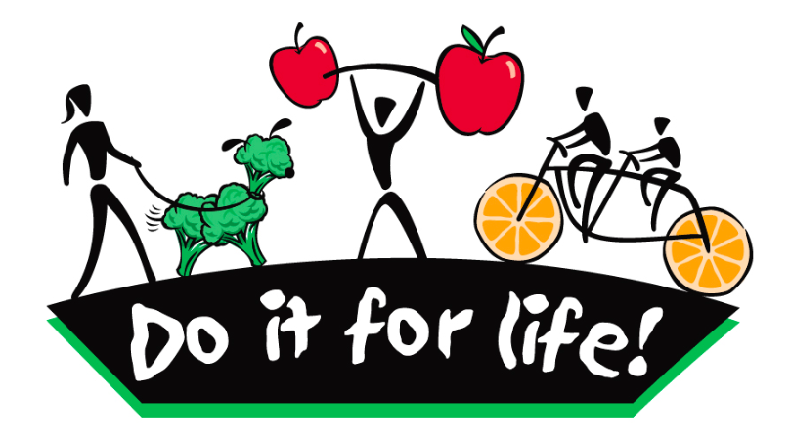 | Active for 60 minutes everyday!  Do 60 exercises!  10 jumping jacks  10 push-ups  10 mountain climbers  10 Crunches or Sit-ups  10 Lunges  10 Burpees or Jumps  Extension:  Can you create your own series of exercises?  Can you repeat?
Physical Fitness Challenge  Arm Muscular Strength  Hold your arms straight out to your side and see how long you can stay in this position. Write down your time.  Plank Muscular Endurance  Hold a plank position (elbows or push-up style) and aim for the amount of minutes in your grade level ( Example 1st = 1 minute)  Jog in Place (Cardiovascular Endurance)  How long can you jog in place without stopping? Aim for the amount of minutes in your grade. Example 4th = 4minutes. Write down your time. | Teach hand washing skills to family members  From the CDC:  - Wet hand with clean water  - Lather and scrub- sing the happy birthday song twice  - Rinse with clean water  - Dry-Using a clean towel or air dry.  Extension: Create a poster and hang in your home. | Create your OWN Physical Education Warm-up  Design a warm-up that could be done in your living room, basement, family room, back yard or anywhere in your house that is safe  Once you have it written out or drawn out on a piece of paper then teach to a family member(s)  Use ideas from your Physical Education teacher.  If you cannot create one then teach your family one that you learned in class.

